The Gardener’s Companion
Balwyn community Garden
412 Whitehorse Road, Surrey Hills 3127
Phone: 9836 7942
Email: reception@balwyncc.org.au
November 2024

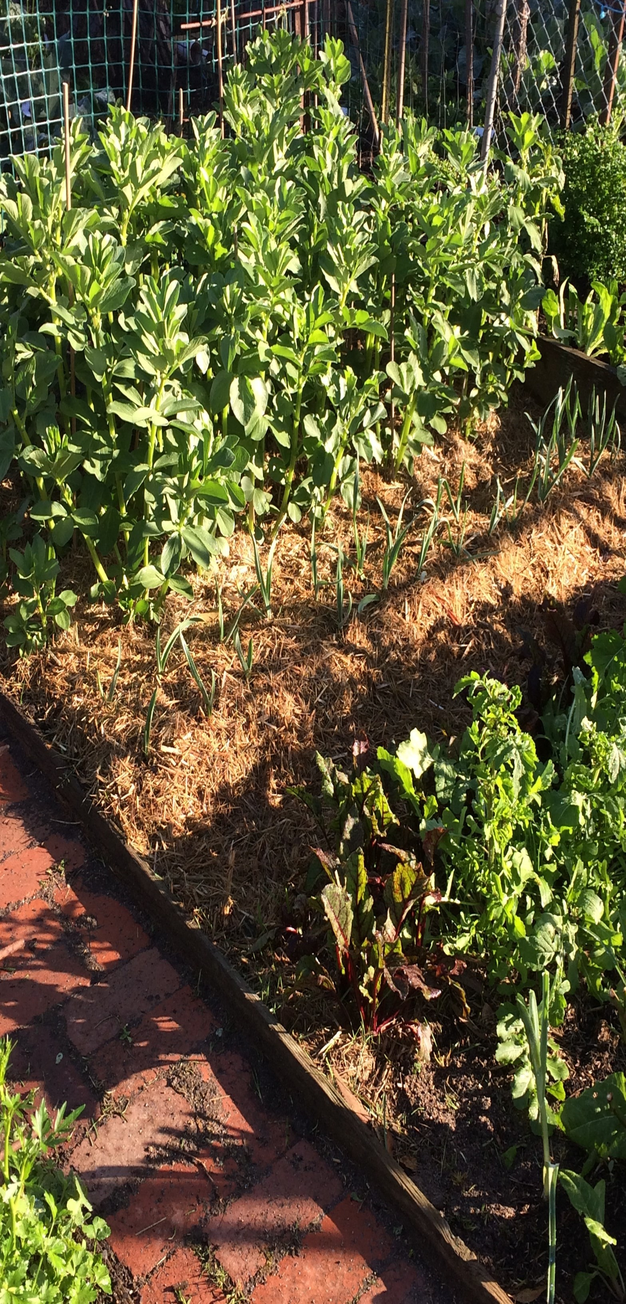

Contents
Balwyn Community Garden Code of Conduct 2
Community Garden Membership Charter 2
Rights 2
Responsibilities 2
Garden Safety and Security 3
Safety 3
Security 3
General Conduct of the Garden 4
Fees 4
Keys 4
Change in Circumstances 4
Allocation of Plots 4
Forfeiture of Garden Plots 4
While on Extended Leave 4
General Maintenance of Plots 5
Visitors to the Garden 5
Animals 5
Control of Garden Pests 5
Garden Tools 5
Sale of Garden Produce 5
Working Bees 5
Types of Plants 6
Soil and Garden Material 6
Building and Other Materials 6
Waste management 6
Water Management 6



Balwyn Community Garden Code of Conduct

The Community Garden is a shared community space, managed by the Community Garden Management Committee which in turn is responsible to the Community Centre Board of Governance through the Centre Director. When participating in garden activities or simply enjoying a visit to the garden, please abide by the Garden Code of Conduct set out below.
- Participants in the garden are asked to be respectful of other gardeners and not act in any way that could spoil the enjoyment of this place for others.
- Gardeners working alone should only undertake gardening tasks appropriate to their abilities for safety reasons.
- All garden tools and equipment should be returned clean and in good condition to the shed at the end of gardening activities.
- Pests and diseases in the garden are to be managed by natural, environmental and biological controls. The use of harmful chemicals in the garden is not permitted.
- Gardeners should not knowingly introduce weedy, prohibited or diseased plants to the garden.
- Pathways and access routes must be kept clear to ensure there are no physical barriers to anyone.
General rubbish bins are not provided. Gardeners are expected to remove their own non-organic refuse, including punnets and labels. Organic refuse can be placed in gardeners’ own compost bins or in the Council supplied green waste bins. It can also be left in a pile on their plot to rot down.

Annual commitment
By paying your membership fees, you reaffirm your commitment to abide by our community garden’s code of conduct each year.

Community Garden Membership Charter

Rights
As a garden member, you have the right to:
- be kept informed about activities and events organised for the garden community.
- have your email contact details kept private by the Community Garden Management Committee and the Community Centre office.
- participate in the Community Garden Management Committee.
- contribute, as appropriate, to decision making processes about the garden.
- feel safe within the garden and be treated with respect by all garden community members.

Responsibilities
As a Garden member you are asked to:
- pay your membership fees by the due date (as communicated by the Centre office).
- abide by the Community Garden Code of Conduct.
- assist in implementing the Code of Conduct by reminding others of its contents if necessary.
- keep weeds in check by not letting them flower or dig them out to avoid them spreading to other plots.
- participate in communal activities that assist ongoing management of the garden and its facilities. This include activities like attending working bees, volunteering to be on the bin roster, sweeping the shed and surrounds, contributing to the newsletter. Our garden flourishes when we all contribute.
- provide your personal details to the Community Centre as requested on your membership application.
- read garden notices and any communications to members about Garden activities and events.
- act in a spirit of co-operation and be respectful towards others in the garden.
- act in a manner that ensures your safety and the safety of others in the garden.
- apply to the Centre Director to have grievances resolved in accordance with the Community Centre’s Dispute Resolution policy.

Garden Safety and Security

Safety
All gardeners must:
Induction
- be inducted before they take over a plot. Gardeners are required to induct anyone who is going to care for their plot while they are away.
Site Safety and Equipment
- Address any unsafe conditions within your capability that may cause harm to self or others.
- Report any unsafe conditions to Centre management.
- Note the location of first aid cabinet in the shed.
- Maintain a tidy plot and adjacent areas by keeping walkways clear of tools, bags, hoses, stakes etc. to prevent trip hazards. Cut back plants that overhang paths.
- Ensure tools, trellises, fencing and stakes are properly secured so that they don’t topple causing personal injury or hazard potential.
- Clean tools before returning to the shed after use.
- Ensure secure storage of permitted pest and disease deterrents (e.g. snail bait in original containers, garlic and chilli sprays stored in a sealed containers).
Only products compatible with organic gardening are permitted to be used within the Community Garden.
- Undertake tasks that are within your capability, e.g. lifting or carrying bags of mulch.
- Use the right tool for the job so excessive force is not needed. Power tools are only to be used as per manufactures user guide and personal capability.
- Not be intoxicated or under the influence of other substances while attending the garden.
Protective Clothing
- Always wear closed in shoes to protect feet from injury.
- Wear comfortable clothing that covers the body to avoid scratches.
- Ensure sun protection by wearing sunscreen and hats as appropriate.
- Take precautions (i.e. wear facemask and gloves) when spreading mulch, compost and fertilisers to avoid inhaling dust and fungal spores, or when spreading pest deterrents like snail bait, Pyrethrum, Derris Dust, etc.

Respectful Conduct
- Treat others with respect. Threatening or abusive behaviour will not be tolerated and may result in termination of membership.
- Be mindful that the community garden is a shared space for the enjoyment of all gardeners, so a degree of flexibility is needed by all by considering the preferences and needs of others.
If gardeners have any concerns about the Garden or about gardeners, they are strongly encouraged to contact a member of the Garden Management Group or the Director of the Centre.

Security
- Gardeners must close and lock the garden gate when leaving the Garden. The shed must also be locked.
- Let other gardeners know when you are leaving so remaining gardeners know who is around or if they will be alone.
- It is advisable to carry a mobile phone when attending the garden in case of an emergency. This is particularly important if no other gardeners are around. Call 000 in case of an emergency or for other matters call the Community Centre on
9836 7942 during office hours – 9am – 4pm, weekdays. Add this number into your phone contacts so it is readily found.
- When working alone it is advisable to keep the gates locked to prevent intruders or an inquisitive passerby entering the garden.
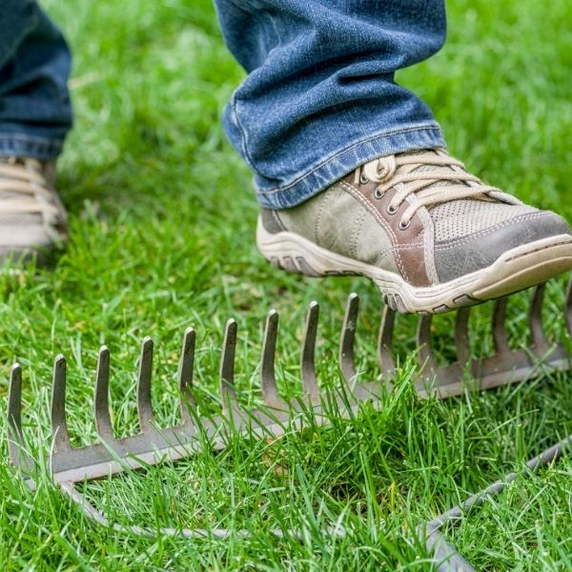

General Conduct of the Garden

We are stewards of this green oasis. Gardeners and visitors should respect the Garden as community space.
Each gardener has the right to quiet enjoyment of the Community Garden.
Gardeners and visitors must not remove any plants, produce or equipment from another gardener’s plot without the permission of the gardener.
Plants and equipment must not be removed from the community garden or the property.
Wilful damage to the community garden will not be tolerated.

Fees
Annual fees are calculated on a charge per square metre.
Fees must be paid no later than the due date, as notified by the Balwyn Community Centre. Failure to do so may result in the plot being forfeited.

Keys
One key will be issued for each garden plot. This key becomes the responsibility of the person to whom it is issued.
When a plot is relinquished, the key must be returned to the Centre.
If the key is lost, its loss must be reported to the Centre as soon as possible. Replacement of a lost key will incur a $60 fee.


Change in Circumstances
Gardeners must advise the Centre of any change in their address (email or postal) or telephone number or if they are no longer eligible to keep their plot.

Allocation of Plots
Only one plot will be allocated per household and members of that household must tend the plot.
Plots are not transferable (no gardener is to allocate their plot to anyone else or give their key to anyone else). The exception is for gardeners who have a friend or relative attending their plot because of an extended absence.
Households may not hold a garden plot at Balwyn Community Garden and another community garden simultaneously.
New gardeners must actively garden their plot within four weeks of it being allocated.

Forfeiture of Garden Plots
Annual renewal of membership is not automatic.
If there is concern about the utilisation and maintenance of a plot, the Garden Management Committee and the Centre Director will contact the plot holder to ascertain if there are any special circumstances. If not, and in the absence of any prompt action to rectify the condition of the plot, the lease on the plot will be terminated.
If a plot holder gains a plot at another community garden, they are required to relinquish the plot at Balwyn Community Garden within thirty days.
When a plot is relinquished, it is the responsibility of the plot holder to clear the plot of all vegetation and any garden equipment and to return the key to the Centre Director. If this is not done, a charge may be incurred.

While on Extended Leave
When gardeners go away and they know their plot will require watering, arrangements need to be made for ongoing care of the plot by asking another gardener, family member or friend to look after it.
Gardeners away for more than four consecutive weeks should inform the Garden Management Committee by email and note:
- the dates of absence.
- the name of the person responsible for the plot.
- the phone number of the person if it is not a Balwyn Community gardener.
If gardeners choose a non-Balwyn Community gardener, they should:
- induct the person and acquaint them with the Code of Conduct along with safety and security measures.
- stress the importance of not losing the key as duplicates cannot easily be provided.
- inform the person that they must only pick produce on the plot they are caring for, not on others in the garden.
- not plant too much if planning to will be away for extended period.
- Mulch or plant a green manure crop to reduce weed growth.

General Maintenance of Plots
Gardeners are responsible for the care and maintenance of their plot throughout the year and to ensure it is well utilised.
Gardeners are required to keep their garden plot, internal paths and the adjacent common pathways, clear of obstruction and in good order.
Mulching of garden plots is strongly encouraged to control weed growth. The use of plastic sheeting or old carpet is not permitted.
Weeds must be removed before they flower and go to seed. This will prevent weeds spreading throughout the garden plots.

Visitors to the Garden
Gardeners are welcome to invite visitors to the garden if they wish. All visitors to the Community Garden are the responsibility of the gardener who invited them into the garden.
Children are welcome in the garden but they must be supervised by adults at all times.
Members of the community who are attending classes or an activity in the Function Centre may occasionally ask to look around the garden. They are welcome but are also the responsibility of the gardener who agreed to them entering the garden.

Animals
Dogs, cats or other pets must not be brought into the Garden. Registered companion animals are accepted.

Control of Garden Pests
No toxic chemicals for pests are to be used in the Community Garden. Gardeners may use safe, environmentally friendly products such as those used in organic gardens and listed below:
- Brown snail bait based on Iron Chelates (e.g. Multiguard snail pellets), not blue or green types
- Dipel (biological control)
- Clensel (garden type)
- Derris Dust (not tomato dust)
- Pyrethrum
- Lux Flakes
- Garlic or Chilli spray
- Beer traps
- Slasher
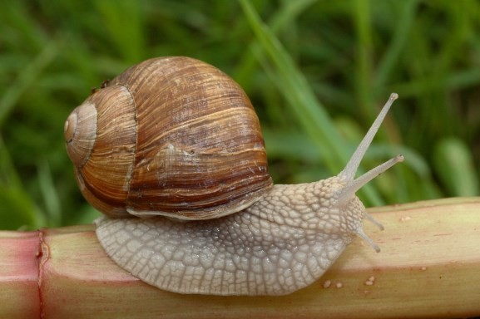

Garden Tools
The Garden key given to each gardener unlocks both gates, and the shed.
It is important that all tools are cleaned and returned to the shed after use and the shed is locked.
A collection of tools is kept in the shed. Some tools are general garden property and others are owned by current gardeners who are happy for others to use them as a loan. If you are leaving your own equipment in the shed, please ensure that it is clearly named.
Tools are to be kept clean and in good condition.
If any tools are missing or require replacement, gardeners should report this to the Garden Management Committee.

Sale of Garden Produce
Plots are available for personal use only. The use of garden plots for growing plants or produce commercially is not permitted and any such use will involve forfeiture of the plot.
Any excess seedlings or produce which gardeners wish to give away can be left on the seat in the garden or in the kitchen of the Centre.
Alternatively, the Balwyn Community Centre hosts a Vegie Swap on the third Sunday of each month from 9am. All produce is welcome including herbs, eggs, fruit, vegetables, honey, seedlings, flowers, compost and more. You are welcome to attend with your excess produce.

Working Bees
The Community Garden Management Group will arrange working bees as necessary and all gardeners must attend to assist in maintenance of the Garden. If this is not possible, gardeners will be expected to contribute by carrying out community gardening tasks such as cleaning the shed, weeding the paths, putting out the green waste bins, at another time.
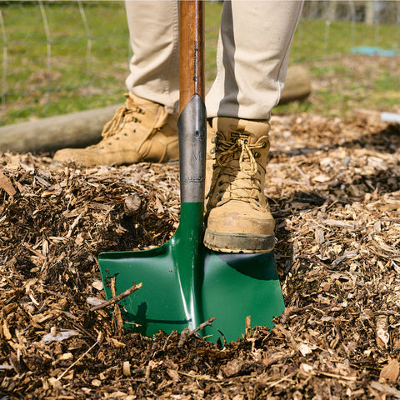

Types of Plants
Community Garden plots are for growing herbs, flowers and vegetables.
Trees, including fruit trees, and large permanent shrubs are not suitable for garden plots.
Care should be taken to ensure that plants do not overshadow neighbouring plots.

Soil and Garden Material
Gardeners are responsible for improving the condition of the soil in their plot. It is important that nutrients are put back into the soil after every season as plants use up soil nutrients as they grow. This may be done by adding manure, compost and mulch and the growing of green manure crops.
It is important that gardeners wear protective gear when handling potting mix and compost. Please refer to the leaflet on the notice board for more information.
If gardeners arrange delivery of soil, manure or other garden material to the Community Garden, it must be moved on to the gardener’s plot on the day of delivery.
When a gardener relinquishes or forfeits their plot, under no circumstances are soil or boundary plinths to be removed from their plot.

Building and Other Materials
Permanent structures must not be built on garden plots or on vacant areas of the Community Garden.
Gardeners need keep in mind that any structure they have installed on the plot must be removed at the end of their tenure.
Gardeners cannot use the Community Garden or shed to store building or other materials.
If gardeners wish to store stakes when not in use, they should be bundled at one end of the garden plot without obstructing pathways.

Waste management
Green waste can be:
- taken home.
- placed in the Council green bins in the Garden.
- put in a compost bin kept on the gardener’s own plot.
- left in a pile on the gardener’s plot to rot down.
The Garden Management Committee will call for volunteers to have their names put on a weekly bin roster. The roster will be available on the shed noticeboard and gardeners will be notified of their duty time by email.
The bins are emptied weekly. The person on duty wheels them to Como Avenue prior to the collection day and returns them to the Community Garden the following day after emptying.
Weeds and diseased plants can be placed in the Council green waste bins. Gardeners should remove all soil from weeds and other plant material and ensure that they don’t overload the bins, so that they are not too heavy for those wheeling them out for collection.

Water Management
Gardeners are encouraged to use the tank water which is supplied from a tap in the centre of the Community Garden. This water comes from tanks that are filled from the roof of the Function Centre.
There are also sufficient taps connected to the mains water supply with hoses to water all plots.
Taps must be turned off prior to leaving the garden.

Watering cans are also provided in the shed.
All gardeners must follow any restrictions on usage of water imposed by the Government in times of drought. Water is a scarce resource and must be used wisely.
Hoses must be handheld and should not be left running unattended.


